Name: ____________________________________________________Date: ________________________________________
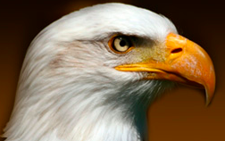
Eagle Nest Observations

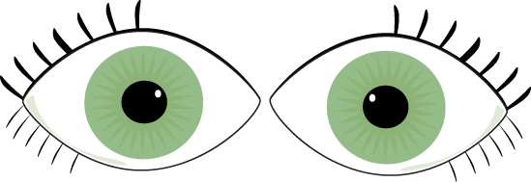 Draw what you see.
Write about what is happening.
_________________________________________________________
_________________________________________________________

What do you hear?
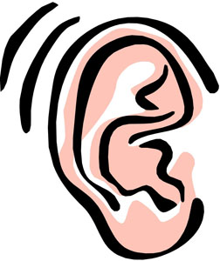
?

I wonder _________________________________________________________________________________________________________

____________________________________________________________________________________________________________________

____________________________________________________________________________________________________________________

